NAME: SHAIK MOHAMMAD IRFAN
REG NO :192472190
COURSE CODE : ITA1416
COURSE NAME :EHICAL HACKING

5-08-26 class practical

Practical 1: View Network Interfaces

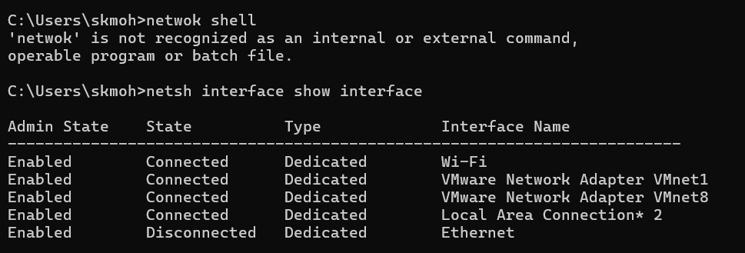

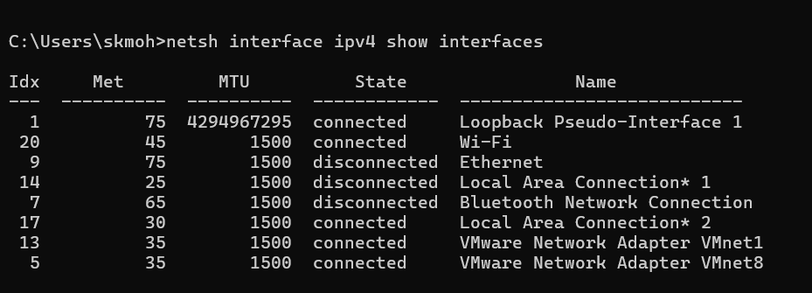

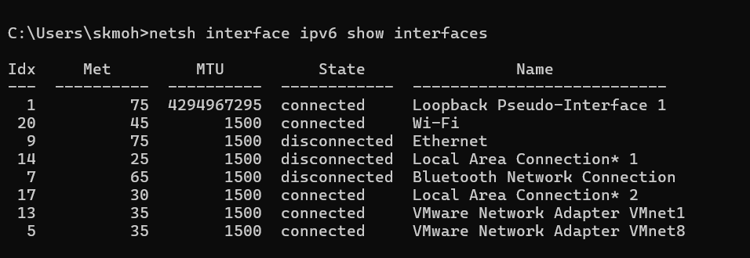

Practical 2: Display IP Configuration

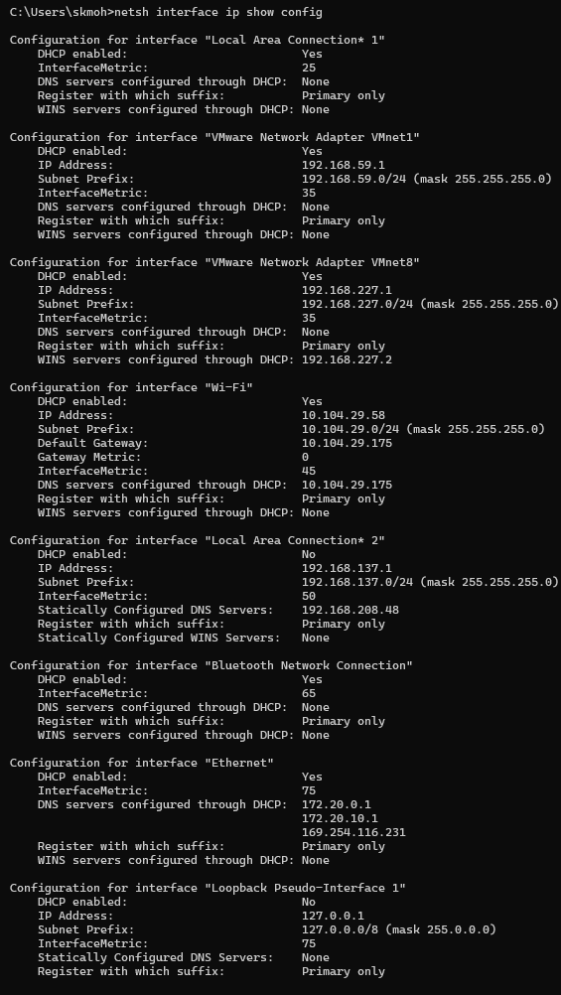
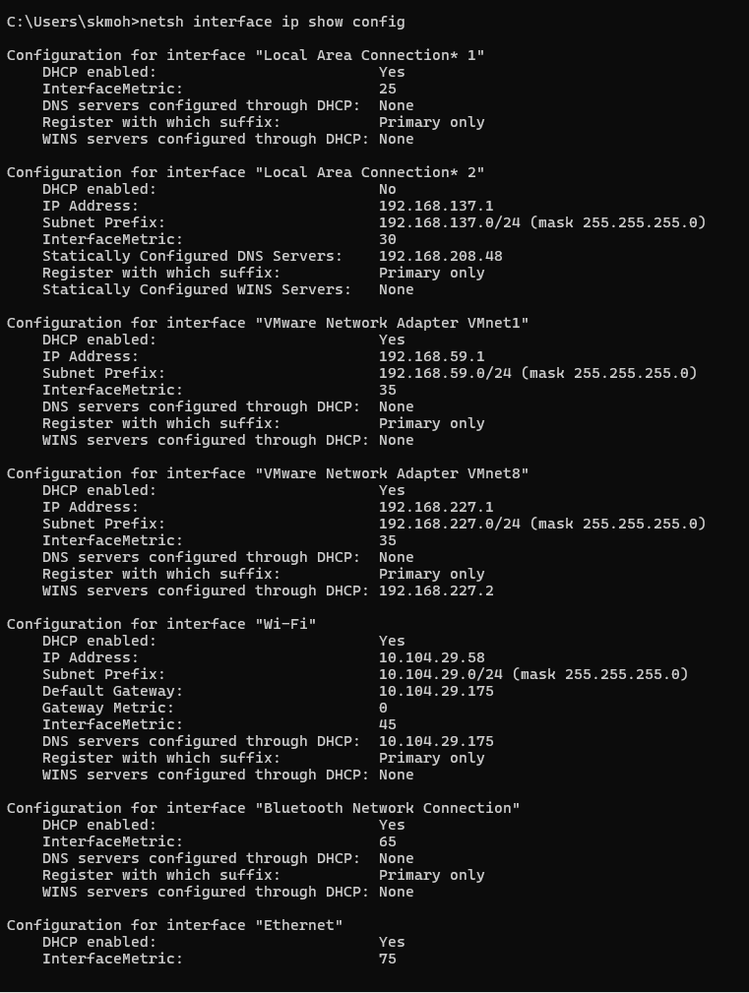

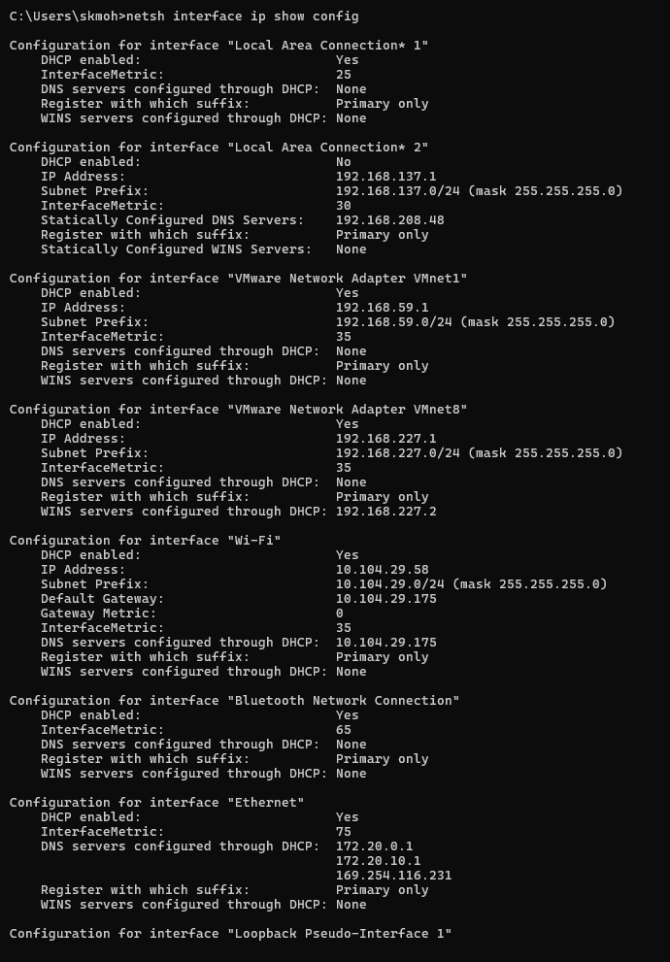

Practical 3: Configure Static IP
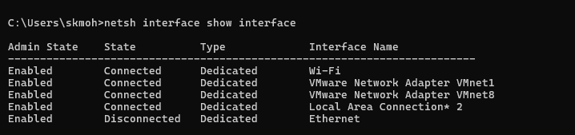

Practical 4: Return to DHCP

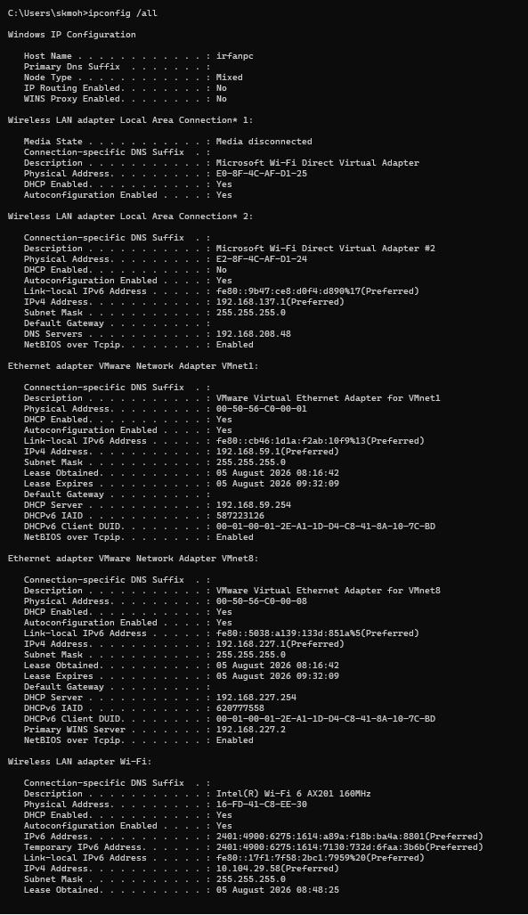
Practical 5: Disable Network Adapter

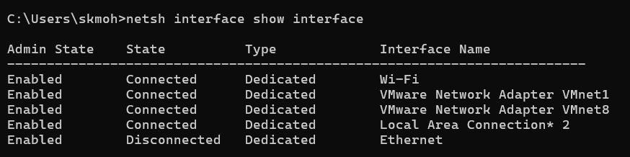

Practical 6: View Wi-Fi Profiles

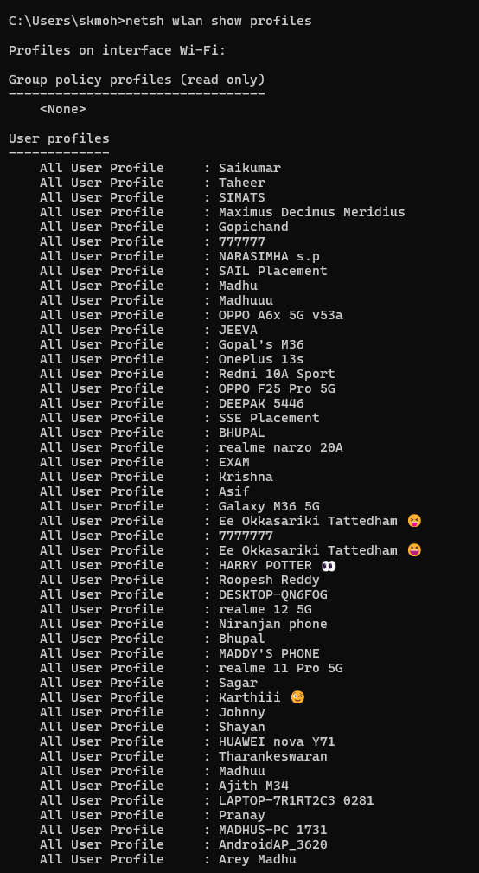
Practical 7: Show Saved Wi-Fi Password

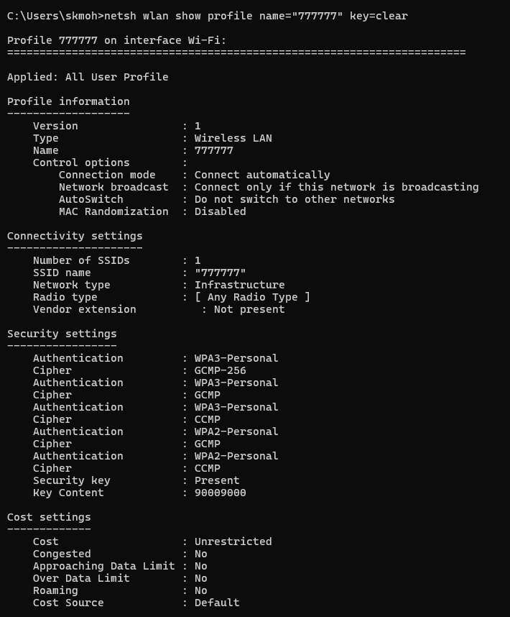

Practical 8: Export Wi-Fi Profiles

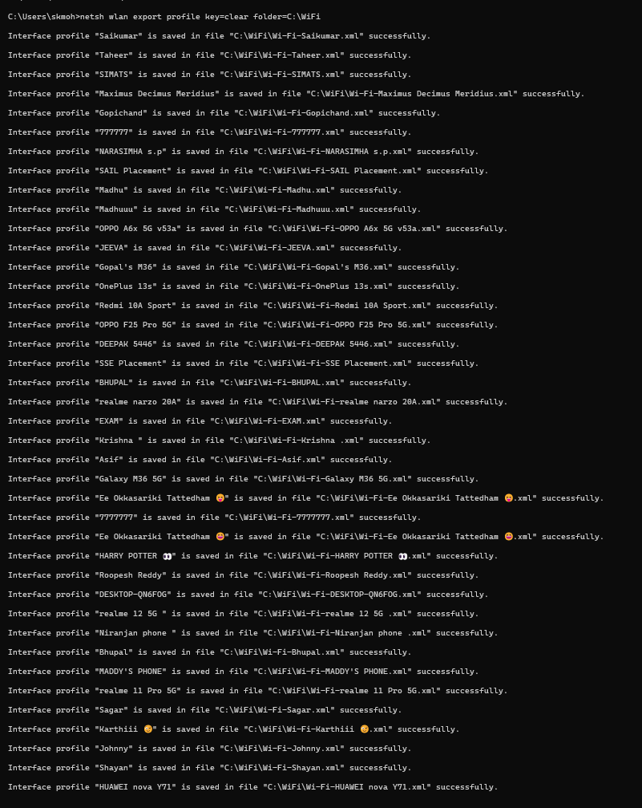

Practical 9: Delete Wi-Fi Profile

Practical 11: Disconnect Wi-Fi

Practical 12: Wireless Driver Information
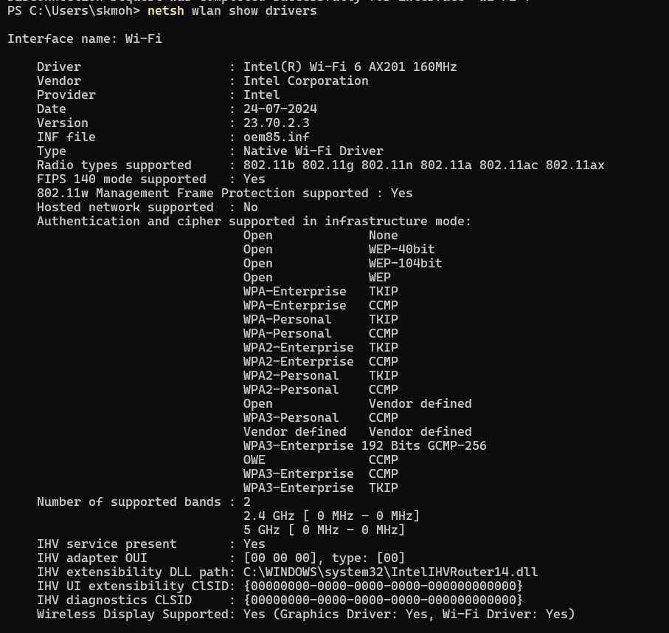

Practical 13: Available Wireless Networks
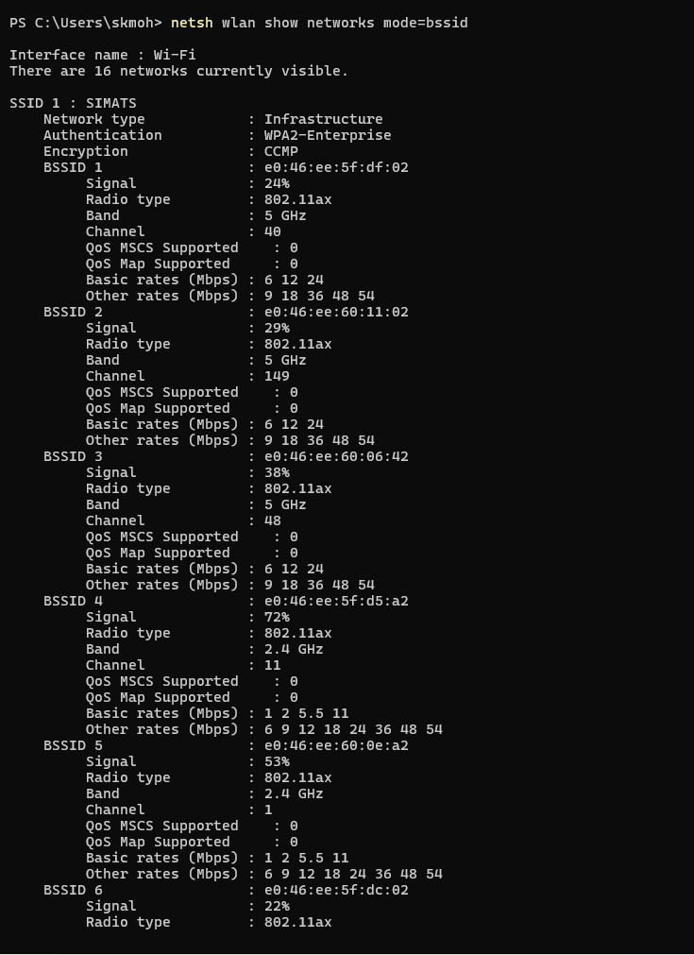

Practical 15: Firewall
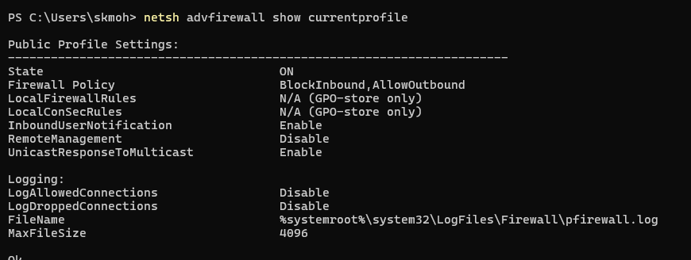

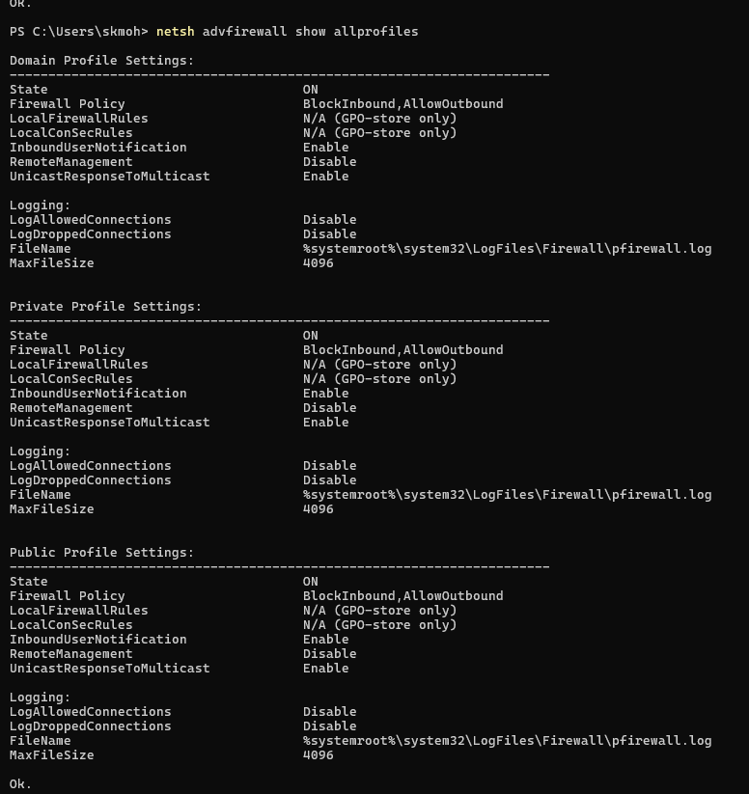

Practical 17: Reset TCP/IP

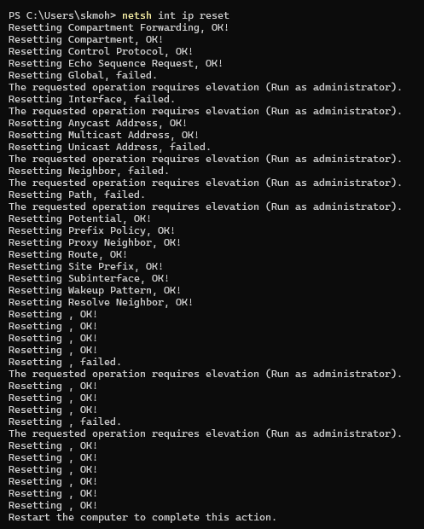

Practical 19: Show Routing Table

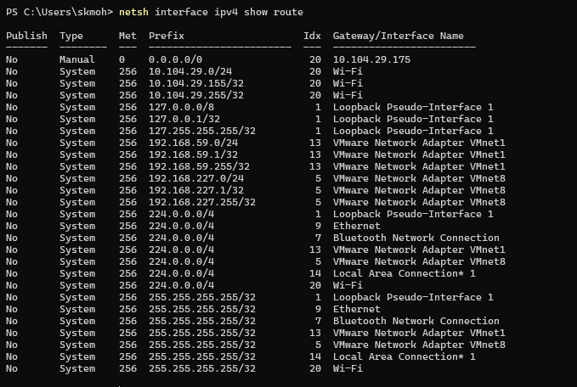

Practical 21: Proxy Settings

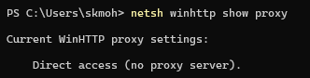

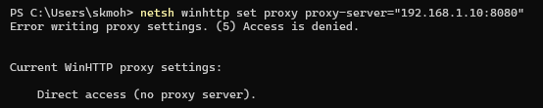

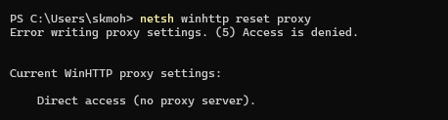

Practical 23: TCP Global Settings
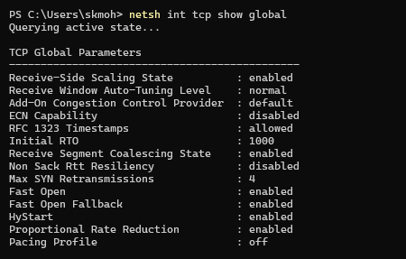

Practical 24: Complete Network Reset
